**From**

The Eye

Computer Science and Engineering Association (CSEA)  
PSG College of Technology

Coimbatore  
  
April 28 2025

**To**  
The Principal  
PSG College of Technology  
Coimbatore

**Subject:** Request for a New Subdomain – theeye.psgtech.ac.in

Respected Sir,

I am writing to formally request the allocation of a new subdomain, **theeye.psgtech.ac.in**, for our club, **The Eye**, which functions under the **Computer Science and Engineering Association (CSEA)**. Previously, we operated under the domain **cseatheeye.com**, but we now seek to migrate to an official subdomain under PSG Tech’s domain for better integration and credibility.

The requested subdomain will be used to host various platforms and resources for The Eye, including but not limited to:

1. **CTF Portal** – A platform to conduct Capture The Flag (CTF) competitions, promoting cybersecurity awareness and practical learning among students.
2. **Community Site** – A dedicated space for discussions, event announcements, and knowledge sharing within our technical community.
3. **Other Assets** – Additional resources, such as event management tools, learning materials, and technical resources, all aimed at fostering technical excellence within the college.

We believe that having this subdomain will help streamline our operations and provide a more structured platform for students interested in cybersecurity and other technical domains. In addition, we request you to kindly assign us an official email adress **[theeye@psgtech.ac.in](mailto:theeye@psgtech.ac.in)** to ensure all correspondence originating from the club remaings authentic and official. Kindly consider our request, and we would be happy to discuss this further at your convenience.

Looking forward to your positive response.

Thank you.

**Yours Sincerely,**

Dinesh T M

Head - Events Resource Management  
The Eye, CSEA  
PSG College of Technology

|  |  |  |  |  |
| --- | --- | --- | --- | --- |
| Eye Club Incharges | | HOD - CSE | Principal | |
| **Website:** | theeye.psgtech.ac.in | | |
| **Description:** | Homepage of the club | | |

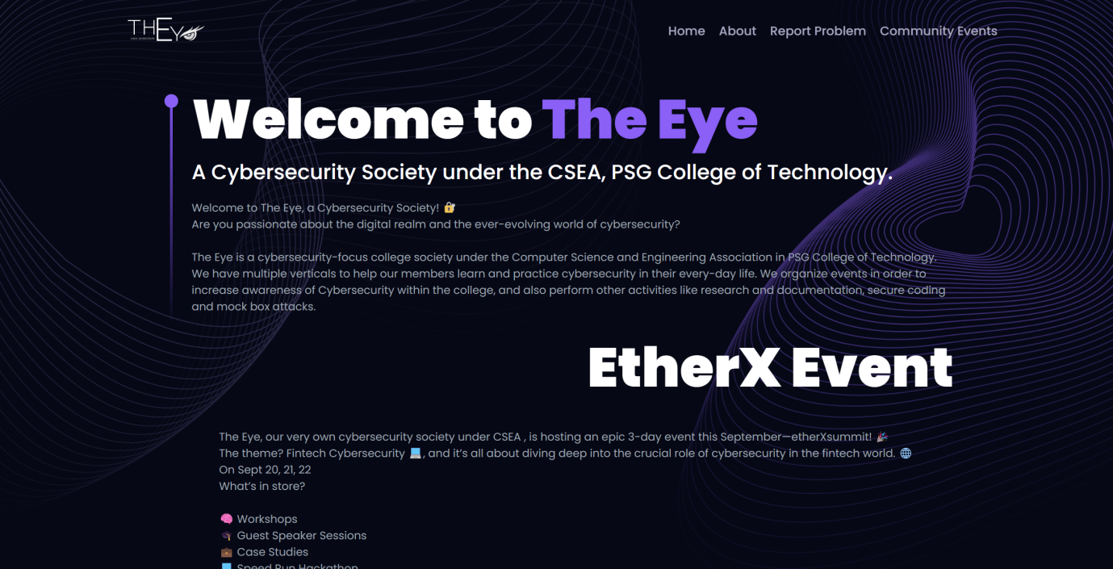

|  |  |
| --- | --- |
| **Website:** | theeye.psgtech.ac.in/community |
| **Description:** | Community page of the club used to connect cybersecurity enthusiasts over trending topics. |

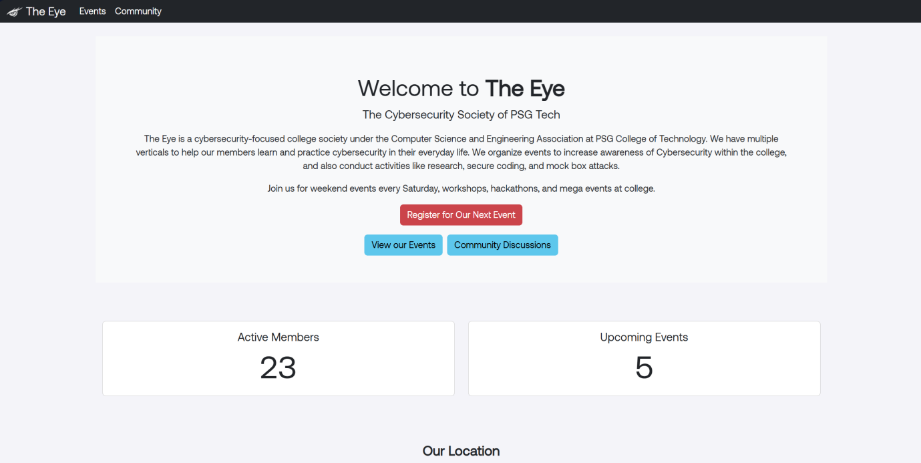

|  |  |
| --- | --- |
| **Website:** | theeye.psgtech.ac.in/ctf |
| **Description:** | Capture the Flag (CTF) portal of the club used to conduct cybersecurity CTF competitions in inter and intra-college events. |

